**TUGAS PRAKTEK ALGORITMA PEMROGRAMAN**

**(Tugas)**



Faathir Akbar Nugroho

4522210033

A

Room 3 : Laila_Josua

**Flowchart (Soal 4)**

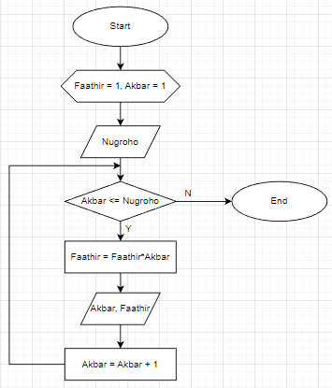

**Pseudocode (Soal 4)**

**Kamus/deklarasi variabel**

Faathir, Akbar, Nugroho : long int

**Algoritma/deskripsi**

Faathir = 1

input(Nugroho)

for(Akbar = 1; Akbar <= Nugroho; Akbar++

Faathir = Faathir * Akbar

print(Akbar, Faathir)

endfor

**Algoritma/Bahasa Alami (Soal 4):**

1. Const Faathir = 1

2. Masukkan isi/nilai variabel Nugroho

3. Selama (Akbar <= Nugroho), maka kerjakan baris 4 sampai 7 kalau tidak bari 8

4. Faathir = Faathir * Akbar

5. Mencetak isi/nilai variabel Akbar

6. Mencetak isi/nilai variabel Faathir

7. Akbar++

8. Selesai

**Program (Soal 4)**

